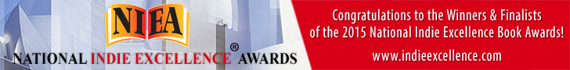

FOR IMMEDIATE RELEASE
Contact: Author LaDonna Marie/912-403-5830/lmbpoetry@gmail.com

2015 NATIONAL INDIE EXCELLENCE AWARDS ANNOUNCED

Local Author receives national recognition from the 9th Annual 2015 National Indie Excellence® Awards!

Atlanta, GA -- The 9th Annual 2015 National Indie Excellence® Awards recognized Lessons: Shattered Pieces Being Restored in the category of Poetry as a Finalist in this year's competition.

This prestigious national award, based in Beverly Hills, California is open to all English language books in print from small, medium, university, self and independent publishers.

The National Indie Excellence® Awards exist to help establish independent publishing as a strong and proud facet of the publishing industry. Recognizing authors that put their heart and soul into their work, the National Indie Excellence® Awards is proud to be a champion of self-publishers and small and independent presses that go the extra mile to produce books of excellence in every aspect. Awarded since 2007, the National Indie Excellence® Awards competition is judged by independent experts from all aspects of the indie book industry, including publishers, writers, editors, book cover designers and professional copywriters.

Winners and finalists are determined based on overall excellence of presentation in addition to the writing. Lessons: Shattered Pieces Being Restored is an Inspirational Poetry Book. Author LaDonna focuses on thoughts about growing pains in life, the ones searching for love, and those who seek to become empowered to grow. It is the author’s hope that each person is able to find the strength to move forward and to seek healing and grow. It is the author’s belief that as you stand strong you will and can make in difficult times. You can rise higher, you can be greater, you can be restored.

“We are proud to announce the winners & finalists whose books truly embody the excellence that this award was created to celebrate, and we salute you all for your fine work, said National Indie Excellence® Awards Award President & CEO, Ellen Reid.

For more information please visit: www.indieexcellence.com

